**Descriptive Wireframe Document**

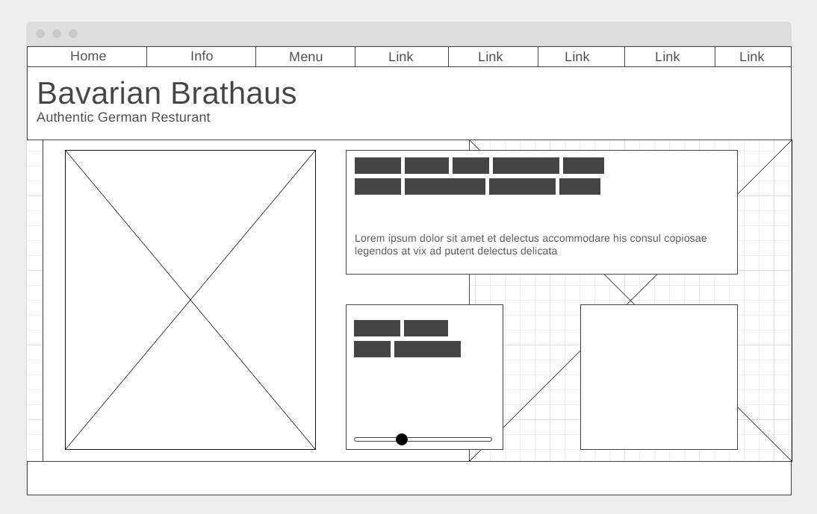

Rationale:   
There are a lot of major issues that must be addressed when redesigning the outdated website. The first thing that was noticed was that there are too many different colour variants and there being a lack of a colour palette. Additionally, I also noticed a lot of the elements on the right are not aligned properly, and some stick out more than others. In terms of accessibility issues, there are many accessibility issues that I noticed. First, the primary image does not include an alt variant, making it impossibly for a text to speech program to describe. Additionally, they depict important information within an image which again, makes it impossible for text to speech programs to decipher that information. Also, the image uses a font that is very difficult to read. Finally for accessibility, they included their social media links in the photo which once again, makes it difficult for accessibility issues. For contrast issues, the brick background creates a huge contrast between the content and the background that completely drowns out the content in front of it. secondly, the logos on the website clash with the colour palette choices on the website and the font on the main logo isn’t legible. Finally, the strange sausage man in the top left corner of the website does not match with any colours within the website and doesn’t link much to the restaurant.

Item #1

Description: Navigation

Font: Text in buttons: 15px Arial

Color: Black

Alignment: In each button: Left Aligned

Media: N/A

Interactivity: Links to both external and internal links; Pinned to top of page so its always at the top of your view when you scroll.

Item #2

Description: Header

Font: N/A

Color: (Background Color) Forest Green

Alignment: ( Full Length – Top of page)

Media: N/A

Interactivity: N/A

Item #3

Description: Title

Font: 40px Arial

Color: White

Alignment: Left Aligned

Media: N/A

Interactivity: N/A

Item #4

Description: Subtitle

Font: 30px Arial

Color: White

Alignment: Left Aligned

Media: N/A

Interactivity: N/A

Item #5

Description: Main Info Box

Font: Headline: 20px Arial; Paragraphs: 15px Arial.

Color: Background Color: White with black shadow around box; Text Color: Black, Forest Green

Alignment: Text: Left align

Media: N/A

Interactivity: N/A

Item #6

Description: Main Picture Box

Font: N/A

Color: N/A

Alignment: Centered

Media: Photo: Something related to Oktoberfest maybe?

Interactivity: ALT tag so that TTS programs can accurately depict the photo to those who are visually impaired.

Item #7

Description: Reviews Box

Font: Headlines: 20px Arial; Paragraphs: 15px Arial

Color: Text: White; Black; Block Color: lighter tone of forest green

Alignment: Text: left aligned

Media: optional images if included in review

Interactivity: links to initial reviews

Item #8

Description: Extra Content Box

Font: If included: 15px Arial

Color: same color as item #7

Alignment: within the box: center aligned

Media: potential for an image to be put in this box if opted for; but not necessary

Interactivity: possibility for interactive element if opted for; but not necessary.

Item #9

Description: Background Photo

Font: N/A

Color: No specific colour; Opacity: 50%; faded edges

Alignment: right aligned

Media: appropriate photo to serve as a background that does not take away from the foreground elements.

Interactivity: N/A

Item #10

Description: Footer

Font: 15px Arial

Color: Text: White; Background: Forest Green

Alignment: Text: Left Aligned

Media: N/A

Interactivity: Link to top of page, information about website.